CYBS 7355 - Penetration Testing and Vulnerability Assessments
Final Exam
Fall 2022

NAME: CHRISTOPHER PHAN
STUDENT ID: 900884326

I certify that this is my own work and I have cited all work that is not mine by quotes and citation or by paraphrasing with citations using APA. I understand that if I have plagiarized or copied materials that are not my own work that I will fail this exam with a grade of zero and be subject to academic review. This includes cutting and pasting. Do not use endnotes or footnotes as this is not the APA method

NAME: CHRISTOPHER PHAN
DATE: 11/9/2022
- Revisit Lab #7: Analyzing network traffic to create a baseline definition
  - Wireshark is for packet capture, while NetWitness is for analysis. The reason why Wireshark is chosen for packet capture is that Wireshark has no limit on the size of the capture files. NetWitness on the other hand is better suited for analysis due to it having a seven-layer protocol analyzer, much more refined and detailed than Wireshark, as well as user-friendly.
  - 6 Source IP addresses were found.
  - 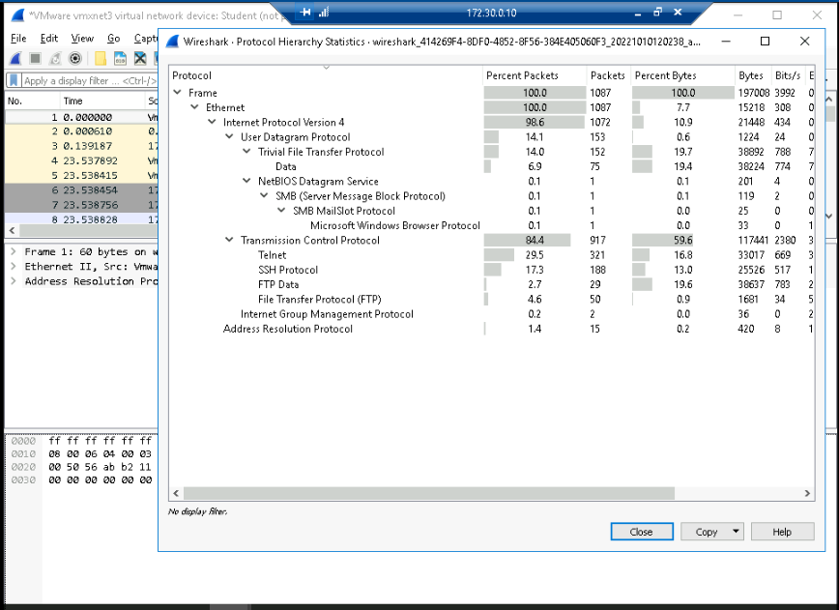
    - This page shows all the protocols that were captured within Wireshark, and the values of each protocol is displayed.
  - 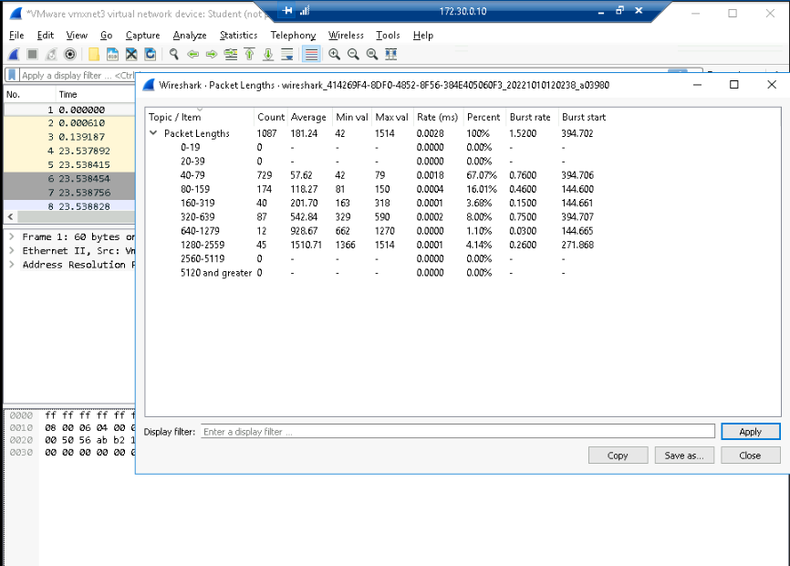
    - The Packet Lengths Distribution page describes the size of the packets that have been captured through Wireshark, describing thing such as how many packets fit within a certain packet length, the minimum and maximum length of packets, and what is the rate packets being captured.
  - The issues that arise from baseline analysis is that it is a continuous process that needs to be monitored with the use of multiple tools, such as NetWitness and Wireshark. As well, with baseline analysis, it simplifies the data, dealing with only large-size packet capture files, so outliers in the data may need to be ignored to create this baseline for network engineers.

- Electromagnetic radiation (EM) forms the basis for all our communication networks. All of our devices leak this radiation in varying amounts, and this leakage can be used to spy upon the communications in our devices and networks. Research the following:
  - Electromagnetic radiation leakage is a highly significant topic, especially in intelligence gathering. It is a way that allows spys to intercept communications due to all electronic devices leak this type of radiation. This radiation leak could cause all sorts of havoc if one party did not take the right procedures in stopping and preventing this leakage going in the wrong hands. Risks such as important information being breached to malicious parties, confidentiality being compromised, and protection of all kinds being nullified. Examples of these risks in real life application is Brazil electronic voting system, the devices used for ballots had this radiation leakage, creating multiple machines showed who voted for what in their ballots. Thus, preventing this leakage should be a priority for any organization that carries information that is confidential and privileged. All networks are privy to these types of eavesdropping attacks, as emenations are created by all computer hardware, meaning that an organization should not only be concerned about software security but hardware security as well. These emenations can include radio broadcasts, signals, sounds, vibrations, visual cues, and lights.

The US’s NSA actually had tried to create a standard to counteract this type of eavesdropping through the development of TEMPEST. This standards includes four principles: (1) distance, (2) shielding, (3) filtering, and (4) masking. All these principles would work in tandem to deflect these attempts of espionage, by making it harder to infiltrate on these emenations, using physical means to stop eavesdroppers.

Another technique that has been developed was “airgap”, which meant that a computer was housed completely isolated from any network and was not connected to the internet. Airgapped computers are extremely hard to breach through means of hacking, and the data can only be accessed through physical means. Airgapped computers are only for highly sensitive and confidential data that should not be connected to any online means. The biggest issue is that it has become harder and harder to implement airgapping in a realistic manner for an organization, as the dependency on technology has grown exponentially. Airgap prevents any tampering, destruction, or manipulation of backup data, unless the malcious actors were capable of physically reaching the device. If a business implements this method, it is a mean of a last resort in response to a crippling disaster, and is a means to sustain the organization.

Another emenation protection technique are Faraday cages, though they are less likely to be implemented professionally in any organization. A Faraday cage acts as shield around any device that is within that cage, completely blocking any electromagnetic radiation from leaking outside. The problem is that this also restricts the device from connecting to anything outside of that cage, as it also blocks signals from leaving too. Usually Faraday cages are put in place of rooms where no information should ever leave it, such as data centers, conference rooms, intelligence spaces. This Faraday cage can prevent any valuable data from leaving ever leaving that room or being eavesdropped from the outside or even hacked from malicious actors trying to peak in the room. Faraday cages are not particularly effective though, and are not mobile whatsoever, so their implementation is seldom used.

Lastly, another technique that is much more deployable and efficient than a Faraday cage is a Stealth wallpaper. The purpose of this Stealth wallpaper is to prevent the leakage or over expansion of a WiFi network, while also allowing devices to send signals outside of this wallpaper. This Stealth wallpaper protects from any emenations or secretion of confidential data, preventing anyone from accessing the WiFi network and hacking into the network. Also, this wallpaper can filter whether devices can send signals out or not, creating some level of control for users who want to deploy this. In combination with any of these techniques and standards, our organization can become stronger against malicious elements who want to eavesdrop on secret information, most notably TEMPEST and Stealth wallpaper, as they would create the greatest benefit at a lower opportunity cost. Though, airgapping can be beneficial based on how valuable and top secret the data that is in need of protection.

- Ransomware – As a CISO, you never really catch a break. The Colonial Pipeline ransomware has come to attention as a formidable ransomware that attacked critical infrastructure. Your CEO wants to know more – specifically what you know about it, what you have done about it, and what you are planning to do about it. Complete a 1-2 page assessment of the Colonial Pipeline malware. Here is a template for the assessment.
  - The Colonial Pipeline attack was a result of ransomware perpetuated by DarkSide, a Eastern European sponsored hacking group that uses RaaS. Reason why Colonial Pipeline was attacked was due to them being the largest gas distributor in the US, being one of the largest energy infrastructure organizations. This attacked was initiated on May 7, 2021, where REvil encrypted all the files within Colonial Pipeline’s servers, and gave instructions on how much must be paid to retrieve the data and when that payment needed to be made. Colonial Pipeline immediately made the choice to shut down the entire company in fear of the ransomware spreading to more valuable assets. On the first day, Colonial Pipeline paid the ransom of $4.4 million to unencrypt the files and to allow business to continue, as damage was piling up as the pipeline had been halted. The attack vector was an exposed password for a VPN account with single factor authentication, where a unactive employee had used the same password to another site that was compromised. As well, it was indicated that legacy systems were inplace, creating more insecurities. After that, DarkSide was capable of accessing Colonial Pipeline’s system freely, thus giving them the ability to implement their ransomware and their strategy of double extortion. Their malware was capable of finding the computer’s name and collect system information. From there, DarkSide selected which files needed to be encrypted based on the directory, slipping away from detection through self-encryption and dynamic API. Lastly, DarkSide’s malware looked for any backups in the system, and immediately disabled them to cripple Colonial Pipeline.

How to contain, prevent, and destroy possibility of such an attack is a tenuous process and must be continually monitored. Colonial Pipeline demonstrated the proper procedures in dealing with a current attack, in that they shut down all systems, notified the proper authorities and reported it, and as well had a digital investigation in how such an attack was possible. Though what Colonial Pipeline could have done was have legitimate backups that were not part of the network, due to them being such a high priority target, keeping all their valuable assets in check. Also Colonial Pipeline should have replaced their legacy hardware and software, as it creates gap in their security due to it not being up-to-par against such attacks. Lastly, Colonial Pipeline should have conducted vulnerability assessments on their system using red teams or audits, as well as implementing multi-factor authentication for the network.

Who is most at risk are companies or businesses that are susceptible to these types of attacks and have a considerable amount of currency, shown through DarkSide’s history, attacking the likes of Toshiba, Elliptic, and CompuCom. What information that needs to be immediately distributed to employees is cybersecurity awareness, and password policy. Employees need to have training on these situations and the consequences of their actions, a password can be as long and complicated, but if used multiple times, its value is null. Education and awareness on these types of topics can strengthen an organization’s security posture, as employees will be more capable and alert on these situations.

- Revisit Lab 8: Auditing a Wireless Network and Planning for a Secure WLAN Implementation. Answer the following questions based on your activities in this lab.
  - Airmon-ng is the command that allows to monitor all the incoming packets. Airodump-ng is what captures all the raw packets and saves them. Aircrack-ng is what used for the cracking of a password through a wordlist. Lastly, aireplay-ng is the command that injects frames that will be used to crack the password.
    - airmon-ng
      - 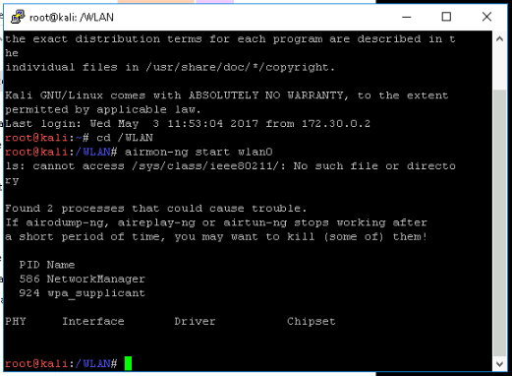

    - airdump-ng
      - 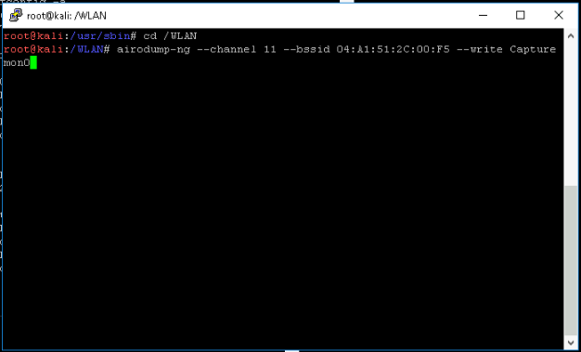
    - aircrack-ng
      - 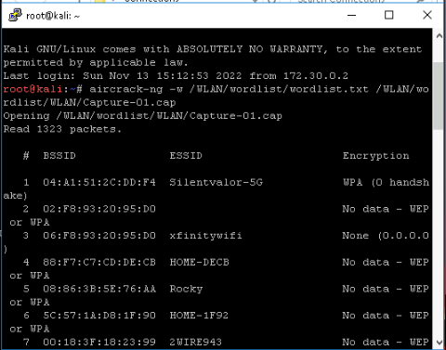

    - aireplay-ng
      - 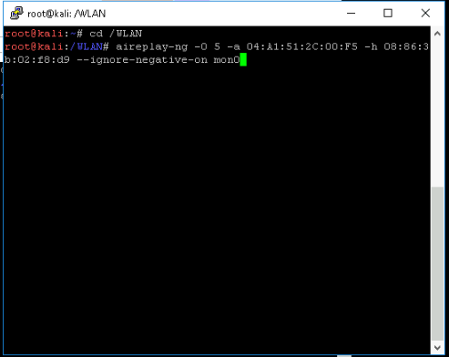
  - There are multiple ways to defend against these types of WLAN applications: (1) implementing a VPN, (2) use highly complex password, (3) do not use sensitive or personal information while on a public WiFi, (4) two-factor authentication, so if a password is breached it does not become a single point of failure, (5) keeping everything as updated as possible, (6) antivirus software, (7) only use “HTTPS” websites, and (8) turn off file sharing so that any files cannot be taken off the device or placed into the device.
  - https://github.com/danielmiessler/SecLists/blob/master/Passwords/WiFi-WPA/probable-v2-wpa-top4800.txt
    - I would first issue airmon-ng to start monitoring all the incoming packets, aireplay-ng is used to inject frames that will be used by aircrack-ng, and then begin using aircrack-ng to begin cracking the password and save it as a wordlist. Making a command akin to this “aircrack-ng -w /WLAN/wordlist/probable-v2-wpa-top4800.txt /WLAN/wordlist/WLAN/Capture-01.cap”, allowing me to see the password of those surfing unprotected public WiFi. With this WPA/WEP key, I am capable of taking over the device and breach their data, acting as the administrator taking files offsite.
  - A synopsis of the article is that there are a trio of criminals who commit wardriving, a technique that involves driving around town looking for unprotected networks so they can take advantage of. This trio would specifically look for networks that currently carry WEP, a highly antique security system that has been replaced with secure and greater substitutes. Upon finding these WEP networks, the trio would immediately start cracking and stealing information to anyone connected to these network, allowing them acces to hundreds of unsuspecting bystanders simply using available WiFi. With their malicious technique, they were able to steal $750,000 and 45.6 million credit cards, with one of their victims being Concur Technology.

One of the main ways to provide a solution to that of Concur Technologies is of course to implement WPA2 and do away with the outdated and obsolete WEP network. Then to encrypt all confidential and personal data, the employee’s information who were breach should have not been so easily compromised and unencrypted. This information needs to be protected, so if a laptop is stolen, the information within is not accessible to malicious actors. As well, Concur should have conducted audits on their security, seeing if they are complying with the current standards of cybersecurity. These three solutions can help prevent these types of incidents where legacy technology is taken advantaged of and businesses fail to recognize the cause of such incidents. Also as a sidenote, Concur Technology could have more protective physical barriers from allowing these criminals from entering unauthorized space, such as locks, keypads, fingerprint scanner, etc.

